|  |  |  |  |  |
| --- | --- | --- | --- | --- |
|  |  | | |  |
|  |  | | |  |
|  | AVAS Audio | | |  |
|  | (MyFeatureId TBD) | | |  |
|  |  | | |  |
|  |  | | |  |
| Document Type | **Feature Document (FD)** | | |  |
| Template Version | **6.0** | | |  |
| Document ID | **document1** | | |  |
| Document Location |  | | |  |
| Document Owner | **Jaime Ramírez** | | |  |
| Document Revision | **A** | | |  |
| Document Status | **Draft** | | |  |
| Date Issued | **2021-04-xx** | | |  |
| Date Revised | **yyyy-mm-dd** | | |  |
| Document Classification | GIS1 Item Number: | **27.60/35** | |  |
| GIS2 Classification: | **Confidential** | |
|  | | | | |
|  | | | | |
| Document Approval | | | | |
| Person | Role | | Email Confirmation | Date |
|  |  | |  |  |
|  |  | |  |  |

Printed Copies Are Uncontrolled

# Disclaimer

**This document contains Ford Motor Company Confidential information. Disclosure of the information contained in any portion of this document is not permitted without the expressed, written consent of a duly authorized representative of Ford Motor Company, Dearborn, Michigan, U.S.A.**

**Copyright, Ó 2016 Ford Motor Company**

This document contains information developed and accumulated by and for FORD MOTOR COMPANY. As such, it is a proprietary document, which, if disseminated to unauthorized persons, would provide others with restricted information, data, or procedures not otherwise available, exposing the FORD MOTOR COMPANY to potential harm.

Employees and suppliers having custody of this specification or authorized to use it must be cognizant of its proprietary nature and ensure that the information herein is not made available to unauthorized persons.

FORD MOTOR COMPANY reserves the right to protect this work as an unpublished copyrighted work in the event of an inadvertent or deliberate unauthorized publication. FORD MOTOR COMPANY also reserves its rights under copyright laws to protect this work as a published work.

This document or portions thereof shall not be distributed outside FORD MOTOR COMPANY without prior written consent. Refer all questions concerning disclosure to the author(s) or to any duly authorized representative of Ford Motor Company.

# Contents

Disclaimer 2

Contents 3

1 Introduction 3

1.1 Document Purpose 3

1.2 Document Scope 3

1.3 Document Audience 3

1.3.1 Stakeholder List 3

1.4 Document Organization 3

1.4.1 Document Context 3

1.4.2 Document Structure 3

1.5 Document Conventions 3

1.5.1 Requirements Templates 3

2 Feature Overview 3

2.1 Purpose and Description of Feature 3

2.2 Feature Variants 3

2.2.1 Regions & Markets 3

2.3 Input Requirements 3

2.3.1 Legal Requirements 3

2.3.2 Trustmark Requirements 3

2.3.3 Industry Standards 3

2.4 Lessons Learned 3

2.5 Assumptions 3

2.6 References 3

2.6.1 Ford Documents 3

2.6.2 External Documents and Publications 3

2.7 Glossary 3

2.7.1 Definitions 3

2.7.2 Abbreviations 3

2.7.3 Parameters / Values 3

3 Feature Context 3

3.1 Feature Context Diagram 3

3.2 List of Influences 3

4 Feature Modeling 3

4.1 Operation Modes and States 3

4.2 Use Cases 3

4.2.1 Use Case Diagram 3

4.2.2 Actors 3

4.2.3 Use Case Descriptions 3

4.3 Driving and Operation Scenarios 3

4.4 Decision Tables 3

5 Feature Requirements 3

5.1 Functional Requirements 3

5.1.1 Error Handling 3

5.2 Non-Functional Requirements 3

5.2.1 Safety 3

5.2.2 Security 3

5.2.3 Reliability 3

5.3 HMI Requirements 3

5.4 Other Requirements 3

5.4.1 Design Requirements 3

5.4.2 Manufacturing Requirements 3

5.4.3 Service Requirements 3

5.4.4 After Sales Requirements 3

5.4.5 Process requirements 3

6 Functional Safety 3

6.1 System Behaviors for HARA 3

6.2 Safety Assumptions 3

6.3 Safety Goals 3

6.4 Functional Safety Requirements 3

6.4.1 <Goal 1 Name> 3

6.4.2 <Goal 2 Name> 3

6.4.3 Derivation of Requirements on Assumptions 3

6.5 (Decomposed) Functional Safety Requirements 3

7 Functional Architecture 3

7.1 List of Functions 3

8 Open Concerns 3

9 Revision History 3

10 Appendix 3

**List of Figures**

Figure 1: Sample Context Diagram 3

Figure 2: Feature Operation Modes and States 3

Figure 3: Use Case Diagram 3

Figure 4: Functional Boundary Diagram 3

**List of Tables**

Table 1: Features described in this FD 3

Table 2: Feature Variants 3

Table 3: Regions & Markets 3

Table 4: Ford internal Documents 3

Table 5: External documents and publications 3

Table 6: Definitions used in this document 3

Table 7: Abbreviations 3

Table 8: Parameters / Values used in this document 3

Table 9: List of Influences 3

Table 10: Operation Modes and States 3

Table 11: Transitions between Operational Modes and States 3

Table 12: List of Actors 3

Table 13: Sample Decision Table 3

Table 14: System Behaviors for HARA 3

Table 15: Functional Safety Assumptions 3

Table 16: Functional Safety Goals 3

Table 17: Requirements Decomposition Table 3

Table 18: List of Functions 3

Table 19: Open Concerns 3

# Introduction

## Document Purpose

A Feature Document (FD) document specifies **what** the feature shall do and how it shall behave from customer perspective. It should also provide reasoning and background **why** we have the feature in the vehicle.

The FD also serves as an Item Definition as defined by ISO26262 for those features, which follow the Ford Functional Safety process.

To get more information about the concept of feature, function and component level abstraction refer to the [Ford RE Wiki](http://wiki.ford.com/display/RequirementsEngineering/Requirements+Engineering+for+SW+Enabled+Features). For details on the Ford Functional Safety (ISO26262) process refer to the [Ford Functional Safety Sharepoint](https://pd3.spt.ford.com/sites/GlobalFunctionalSafety/Pages/default.aspx).

## Document Scope

This Feature Document (FD) specifies the following features:

|  |  |  |  |
| --- | --- | --- | --- |
| **Feature ID** | **Feature Name** | **Owner** | **Reference** |
| <Add VSEM Global Feature Dictionary ID> | AVAS Audio | Dmart468 | <Add VSEM Link> |
|  |  |  |  |

Table 1: Features described in this FD

## Document Audience

The FD is written by the feature owner of <AVAS Audio>. All Stakeholders, i.e., all people who have a valid interest in the feature should read and, if possible, review the FD. It needs to be guaranteed, that all stakeholders have access to the currently valid version of the FD.

**#Hint:** The FD template has the IP Classification “Proprietary” by default. IP Classification “Confidential” might be required in some cases, e.g. by Ford Functional Safety.

**#Macro:** [Add Ins -> Edit Document Properties macro](http://wiki.ford.com/display/RequirementsEngineering/How+to+use+the+Specification+Templates#HowtousetheSpecificationTemplates-EditDocProperties) (select “Proprietary” for “Document Classification”)

### Stakeholder List

For the latest list of stakeholder of the feature and their influence refer to <Put VSEM Link here>.

**#Hint:** Refer to [Ford RE Wiki – Stakeholder List](http://wiki.ford.com/display/RequirementsEngineering/Stakeholder+Analysis) on how to create a stakeholder list. The stakeholder list should be stored in VSEM in the pseudo folder “General Data Artifacts” of the corresponding feature.

## Document Organization

### Document Context

Refer to the [Specification Structure page](http://wiki.ford.com/display/RequirementsEngineering/Specification+templates) in the [Ford RE Wiki](http://wiki.ford.com/display/RequirementsEngineering/Requirements+Engineering+for+SW+Enabled+Features) to understand how the FD relates to other Ford Requirements Documents and Specifications.

### Document Structure

The structure of this document is explained below:

**Section 1** – Introduction how to use this document including responsibilities and requisite documents. Explains the terminology. Gives a clarification of the definitions, concepts and abbreviations used in the document.

**Section 2** – Feature Description. States briefly the background and the purpose of the feature, feature variants and corresponding regions and markets. Also includes input requirements, assumptions and constraints.

**Section 3** – Feature Context describes all external entities, which have an influence on the feature.

**Section 4** – Feature Modeling. Contains Use Case, Driving Scenarios, State Charts to describe the functional behavior of the feature.

**Section 5** – Safety. Lists System Behaviors and Safety Goals of the feature.

**Section 6** – Feature Requirements. Lists functional and non-functional requirements of the feature.

**Section 7** – Architecture. Shows the coarse architecture, which the feature requirements are deployed to. Describes the elements and the boundary of the feature as well as the decomposition and distribution of associated functions.

**Section 8** – List of Open Conerns

**Section 9** – Document Change History including a list of new or modified requirements. The requirements in this document are tagged, and this section contains different types of tables listing all, new, or changed requirements by their title and page no.

**Section 10** – Appendix

**#Hint:** All sections are mandatory, unless explicitly marked by the tag “#Classification” as “optional” or as applicable e.g. to certain domains like “Functional Safety”.

## Document Conventions

### Requirements Templates

Each requirement, use case or scenario in this specification shall follow the corresponding template given in the document template *Specification_Macros.dotm* at [RE Wiki - Specification Templates](http://wiki.ford.com/display/RequirementsEngineering/Specification+templates?src=contextnavpagetreemode).

**#Hint:** The Specification_Macros.dotm template also provides macros to insert the requirement templates. Refer to “[How to use the Specification Templates](http://wiki.ford.com/display/RequirementsEngineering/How+to+use+the+Specification+Templates?src=contextnavpagetreemode)” on how to enable the macros and the requirements templates in this specification.

The requirements macro and requirements templates also enable the import of the specification to VSEM (refer to ["How to import specifications into VSEM as separate requirements"](http://wiki.ford.com/pages/viewpage.action?pageId=104991616&src=contextnavpagetreemode)).

#### Identification of requirements

The unique requirement ID given in the headline of any requirement follows the requirement throughout the development process. The requirement ID format follows a well-defined syntax.

All identifiers in a FD shall be composed of 4 parts:

* A leading prefix, which indicates the type of requirement (R=Requirement, UC=Use Case, SC=Scenario, …)
* A prefix, which indicates the abstraction level (F=Feature, FNC=Function, CMP = component).
* Followed by a name, indicating the scope, which the requirement belongs to (e.g. feature or function name )
* Ending with the actual requirement number

*Example:*

*R_F_AutoLamps_00004* This is the fourth requirement on feature level for the feature Autolamps.

#### Requirements Attributes

The templates provided by *Specification_Macros.dotm* define a list of attributes for each requirement. This helps to classify the requirement. The attributes are explained at [RE Wiki - Requirements Attributes](http://wiki.ford.com/display/RequirementsEngineering/Requirements+Attributes?src=contextnavpagetreemode).

# Feature Overview

## Purpose and Description of Feature

AVAS audio allows drivers of battery powered vehicles to comfortably/safely drive at low speeds knowing that the vehicle will emit a subtle sound that will make pedestrians aware of vehicle presence, thus preventing collisions.

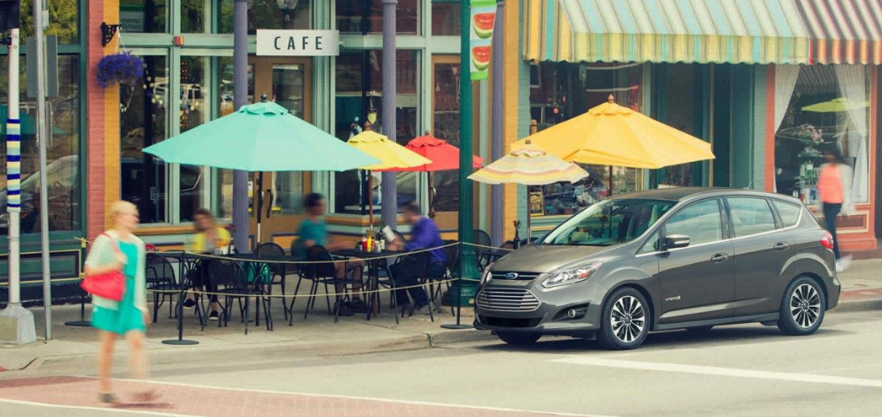

Image 1: AVAS audio descriptive feature image

**#Hint:** Some descriptive text to explain the purpose and functionality of the feature.

## Feature Variants

**#Hint:** Definitions for different variants of the feature (if applicable). Give each variant a descriptive name by which it can be referenced further on in the document. If no variant exists, state “No Feature Variants”.

The Variant Description should give a short informative text which describes the variants of the feature.

|  |  |  |
| --- | --- | --- |
| Variant Name | Variant Description | Remarks |
| **AVAS Audio** | Audio will be active only while the vehicle is propelling at speeds from 0 to 50 kph. | Described in this document |
| **AVAS Audio for full vehicle speed range** | Audio will be active for the entire vehicle speed range. | Described in this document |

Table 2: Feature Variants

### Regions & Markets

**#Hint:** Description of purpose and functionality of the feature. If there is no variant, give feature name in first column.

|  |  |  |  |  |  |  |
| --- | --- | --- | --- | --- | --- | --- |
| **Market /**  **Region**  Variant Name | **North America** | **South America** | **Europe** | **Middle East / Africa** | **Asia / Pacific** | **China** |
| **AVAS Audio** | *Mandatory* | Optional | Mandatory | Optional | Optional | Mandatory |
| **AVAS Audio for full vehicle speed range** | *Optional* | Optional | Optional | Optional | Optional | Optional |

Table 3: Regions & Markets

## Input Requirements

**#Hint:** List all input requirements, which are relevant for the feature. Typically, attribute requirements, legal requirements as well as national and international standards have to be considered.

### Legal Requirements

2.3.1.1 North America:

Federal Motor Vehicle Safety Standard No. 141, Minimum Sound Requirements for Hybrid and Electric Vehicles

2.3.1.2 EU:

UN regulation No.138 Uniform provisions concerning the approval of Quiet Road Transport Vehicles with regard to their reduced audibility

E/ECE/324/Rev.2/Add.137/Rev.1

E/ECE/TRANS/505/Rev.2/Add.137/Rev.1

2.3.1.3 China:

Acoustic vehicle alerting system of electric vehicles running at low speeds GB/T 37153-2018

Technical Specifications for Safety of Power-driven Vehicles Operating on Roads GB7258-2017

### Trustmark Requirements

Currently there are no Ford Trustmark requirements for this feature.

### SDS Requirements

2.3.3.1 AVAS Vehicle Corrosion Resistance RQT-132201-703792

2.3.3.2 AS Power Wash Protection RQT-132201-701775

2.3.3.3 AVAS Joints RQT-132201-701769

2.3.3.4 AVAS Vehicle Wash Protection RQT-132201-703794

2.3.3.5 AVAS SW Functionality RQT-132201-703794

2.3.3.6 AVAS Damageability Protection RQT-132201-701751

2.3.3.7 AVAS Squeak & Rattle RQT-132001-703787

### Industry Standards

Currently no industry standards are available regarding this feature and this informational level.

## Lessons Learned

2.4.1 AVAS Quality History

2.4.2 AVAS Front Speaker Package Design Rule

2.4.3 AVAS Rear Speaker Package Design Rule

**#Hint:** Additional information and lessons learned from previous development or related features. A typical source for Lessons Learned is the FMA Quality History.

**#Functional Safety:** In context of Functional Safety Lessons Learned and similar information will be used to check the completeness of the Functional Safety Goals and assumptions in the Hazard Analysis and Risk Assessment (HARA).

**#Link:** [Ford Functional Safety Sharepoint](https://pd3.spt.ford.com/sites/GlobalFunctionalSafety/Pages/default.aspx)

## Assumptions

2.5.1 AVAS Audio output assumes two dedicated outputs, one for Front Speaker and one for Rear Speaker.

2.5.2 Regardless of the vehicle line application AVAS audio shall drive 2 speakers.

**#Classification**: Optional

**#Hint:** A list of known assumptions concerning the effects of the feature’s behavior on other features or elements (i.e., dependencies) as well as assumptions on the behavior expected by the feature (e.g. known limitations). During the course of the feature development most of those assumptions are typically either converted into actual requirements or discarded at some point – such that this chapter remains mostly empty. For assumptions, which are relevant for the Functional Safety process refer to chapter 6.2 “Safety Assumptions”

## References

### Ford Documents

List here all Ford internal documents, which are directly related to the feature.

| **Reference** | **Title** | **Doc. ID** | **Document Location** | **Revision** |
| --- | --- | --- | --- | --- |
|  | AVAS Foundation Documents |  | AVAS SharePoint | May-25-2018 |
|  | AVAS SW Functional Specification |  | AVAS SharePoint | Oct-16-2018 |
|  | SW Functional Specification Data Dictionary |  | AVAS SharePoint | Oct-16-2018 |

Table 4: Ford internal Documents

### External Documents and Publications

The list of external documents could include books, reports and online sources.

**#Hint:** You may refer to [IEEE Citation Reference](http://www.ieee.org/documents/ieeecitationref.pdf) on how to format a reference.

| **Reference** | **Document / Publication** | **Document Location** |
| --- | --- | --- |
| [bbb] |  |  |
|  |  |  |

Table 5: External documents and publications

## Glossary

**#Hint**: Terms, concepts and abbreviations used in the document shall be defined and illustrated here. Note that changes to terms and/or concepts described in this section tend to cause major updates to this document.

The tables below have feature specific definitions and abbreviations. For additional, non-feature specific terms please refer to the [RE Glossary](http://wiki.ford.com/display/RequirementsEngineering/Glossary?src=contextnavpagetreemode)

### Definitions

| **Definition** | **Description** |
| --- | --- |
| PACM | Alternate name for AVAS, it stands for Pedestrian Alert Control Module |
| AVAS | Approaching Vehicle Audible system |
| Sounders | AVAS Speakers front or rear |
| ECU | Electronic Control Module |
| Settings File | Main Audio calibration file |
| Wave File | .wav file played back |
| SW Strategy | AVAS application SW |

Table 6: Definitions used in this document

### Abbreviations

| **Abbr.** | **Stands for** | **Description** |
| --- | --- | --- |
|  |  |  |
|  |  |  |
|  |  |  |

Table 7: Abbreviations

### Parameters / Values

| **Name** | **Description** | **Range / Resolution** |
| --- | --- | --- |
|  |  |  |
|  |  |  |
|  |  |  |

Table 8: Parameters / Values used in this document

# Feature Context

## Feature Context Diagram

**#Hint:** High level diagram of feature interactions with the environment, people or other feature or other external entities.

**#Link:** [RE Wiki - Context Diagram](http://wiki.ford.com/pages/viewpage.action?pageId=107676234&src=contextnavpagetreemode)

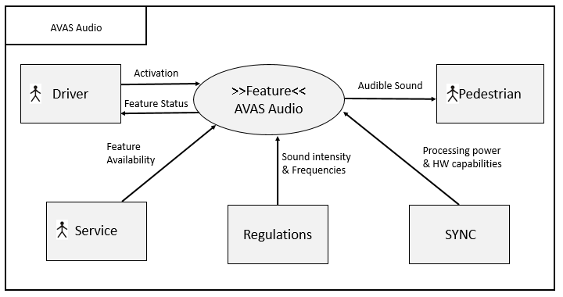

Figure 1: Sample Context Diagram

## List of Influences

|  |  |  |
| --- | --- | --- |
| **ID** | **External Entity** | **Influence Description** |
| I1 | Driver | Likes / dislikes the sound. Is/Isn’t able to hear the sound on the passenger compartment. |
| I2 | Service | Performs SW update / part change procedures |
| I3 | Regulation | Determines: minimum SPL, frequencies to be used and test conditions for which the feature will be rated. |
| I4 | SYNC/Core Audio Group | Establish minimum DSP processing capabilities to processes audio, determines HW to be used & drives AVAS speaker outputs. |
| I5 | Pedestrians | Relate sound to moving vehicle (desired) |

Table 9: List of Influences

# Feature Modeling

## Operation Modes and States

**#Classification:** Optional (Mandatory for Functional Safety)

**#Link:** [RE Wiki – State Charts](http://wiki.ford.com/display/RequirementsEngineering/State+Charts?src=contextnavpagetreemode)

**#Hint:** State Charts are a popular means to express feature behavior in terms of states and modes. An advantage of this state machine like approach is that consistency can be easily verified.

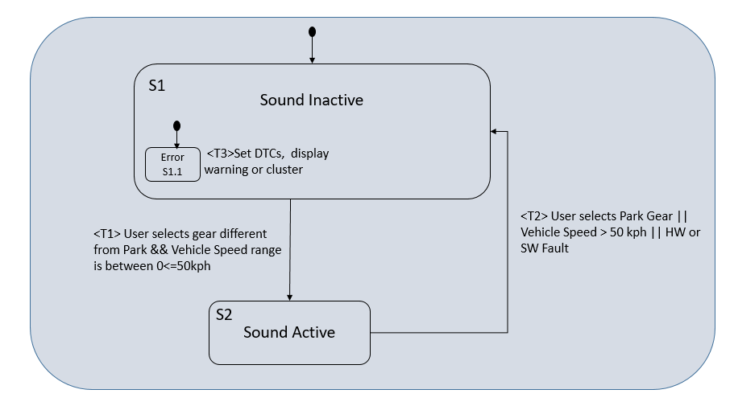

Figure 2: Feature Operation Modes and States

|  |  |  |
| --- | --- | --- |
| **State** | **Description** | **Requirements Reference** (optional) |
| S1- Sound Inactive | No AVAS Audio playback. System is operational and in standby. |  |
| S1.1- Error | No AVAS Audio playback. Any HW or SW fault will mute AVAS, display a cluster warning and set the corresponding DTCs. |  |
| S2 - Sound Active | AVAS Audio is playing normally. All signals required are present. |  |

Table 10: Operation Modes and States

|  |  |  |
| --- | --- | --- |
| **Transition ID** | **Description** | **Requirements Reference**  (optional) |
| T1 | Customer’s vehicle is on, Gear is different from Park and Vehicle speed is with 0 to 50 kph. |  |
| T2 | Customer has shifted to Park or is driving at speeds higher than 50 kph. |  |
| T3 | AVAS HW or SW error present |  |

Table 11: Transitions between Operational Modes and States

## Use Cases

**#Classification:** Optional

**#Link:** [RE Wiki – Use Cases](http://wiki.ford.com/display/RequirementsEngineering/Use+Cases+Overview?src=contextnavpagetreemodehttp://wiki.ford.com/display/RequirementsEngineering/Use+Cases?src=contextnavpagetreemode)

### Use Case Diagram

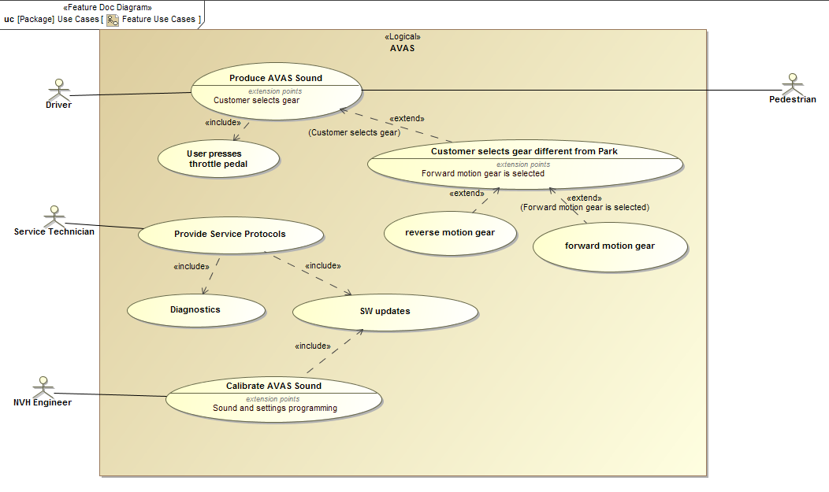

Figure 3: Use Case Diagram

### Actors

| Actor | Description |
| --- | --- |
| Driver | Turns on vehicle, changes gears, presses throttle pedal, drives. |
| Service Technician | Verifies feature status, changes system components, updates SW. |
| NVH Engineer | Calibrates AVAS Sound, create sound. |
| Pedestrian | Hear AVAS sound, relate sound to moving vehicle (desired) |

Table 12: List of Actors

### Use Case Descriptions

**#Classification:** Optional

**#**

###UC_F_MyFeature_00001### AVAS Audio playback

|  |  |  |
| --- | --- | --- |
| **Purpose** |  | Start AVAS Audio playback |
| **Actors** |  | Driver |
| **Precondition** |  | Vehicle is in normal mode |
|  |  |  |
| **Main Flow** | M1 | Driver sits in the vehicle and turns it on. |
|  | M2 | Driver selects a Gear different from Park. |
|  |  |  |
| **Post-condition** |  | AVAS Audio playback starts |

###UC_F_MyFeature_00002### AVAS Audio playback with vehicle speed

|  |  |  |
| --- | --- | --- |
| **Purpose** |  | Introduce pitch shift to AVAS Audio |
| **Actors** |  | Driver |
| **Precondition** |  | Vehicle is in normal mode |
|  |  |  |
| **Main Flow** | M1 | Driver sits in the vehicle and turns it on. |
|  | M2 | Driver selects a Gear different from Park. |
|  | M3 | Driver presses throttle pedal an vehicle begins to move |
|  |  |  |
| **Post-condition** |  | AVAS Audio playback pitch shifts depending on vehicle speed |

###UC_F_MyFeature_00003### AVAS Service Protocols

|  |  |  |
| --- | --- | --- |
| **Purpose** |  | Diagnose AVAS SW or HW Errors |
| **Actors** |  | Service Technician |
| **Precondition** |  | Vehicle is in normal mode, OBD II port has Diagnostic HW connected. |
|  |  |  |
| **Main Flow** | M1 | Service Technician reads DTC’s from AVAS. |
|  | M2 | AVAS responds with DTC information |
|  |  |  |
| **Post-condition** |  | AVAS reports DTC information about the system |

###UC_F_MyFeature_00004### AVAS Sound Calibration/SW updates

|  |  |  |
| --- | --- | --- |
| **Purpose** |  | Update AVAS SW files |
| **Actors** |  | Service Technician, NVH Engineer |
| **Precondition** |  | Vehicle is in normal mode. Vehicle is in Accessory Mode & OBD II port has Diagnostic HW connected |
|  |  |  |
| **Main Flow** | M1 | Service Technician/ NVH Engineer performs bus query to review SW files/ part numbers on ECU. |
|  | M2 | Service Technician / NVH Engineer enters extended diagnostic session to write on the ECU. |
|  | M3 | Service Technician / NVH Engineer downloads required SW files (Secondary bootloader, SW Strategy, Settings file, wave file) to the ECU. |
|  |  |  |
| **Post-condition** |  | HW with AVAS SW reboots, ECU now reports updated part numbers if download was successful. |

**Macro:** [Add Ins -> Add Requirement macro](http://wiki.ford.com/display/RequirementsEngineering/How+to+use+the+Specification+Templates#HowtousetheSpecificationTemplates-AddNewRequirement) (select “Use Case” as type)

## Driving and Operation Scenarios

**#Classification:** Optional (Mandatory for Functional Safety)

**#Macro:** [Add Ins -> Add Requirement macro](http://wiki.ford.com/display/RequirementsEngineering/How+to+use+the+Specification+Templates#HowtousetheSpecificationTemplates-AddNewRequirement) (select “Scenario” as type)

**#Functional Safety:** Driving and operating scenarios which impact the functionality of the feature can be used to check, if the situation analysis in the HARA is complete

**#Link:** [RE Wiki – Driving Scenarios](http://wiki.ford.com/display/RequirementsEngineering/Driving+Scenarios?src=contextnavpagetreemode)

###SC_F_MyFeature_00001### Pedestrian interaction with AVAS

|  |  |
| --- | --- |
|  | |
| **Short Description** | Distracted/vision impaired pedestrian at a crossing is made aware of vehicle presence due to AVAS sound |
| **Condition** | Street, rural or urban area |
| **Reference** |  |

|  |  |
| --- | --- |
| **Flow of Actions** | |
| 1 | The driver is actively driving the vehicle |
| 2 | The vehicle is approaching a vision impaired or distracted pedestrian |
| 3 | The driver is inattentive or doesn’t slow down and the vehicle will hit the pedestrian without system intervention |
| 4 | The vehicle’s AVAS sound helps make the pedestrian aware of vehicle presence. |
| 5 | Pedestrian is able to avoid collision with the vehicle |
| 6 | Scenario ends |

###SC_F_MyFeature_00002### Pedestrian interaction with AVAS (backing up)

|  |  |
| --- | --- |
|  | |
| **Short Description** | Distracted/vision impaired pedestrian is made aware of vehicle presence due to AVAS sound as the vehicle is backing up |
| **Condition** | Parking lot, street, rural or urban area |
| **Reference** |  |

|  |  |
| --- | --- |
| **Flow of Actions** | |
| 1 | The driver is actively backing up the vehicle |
| 2 | The vehicle is approaching a vision impaired or distracted pedestrian |
| 3 | The driver is inattentive, or doesn’t slow down and the vehicle will hit the pedestrian without system intervention |
| 4 | The vehicle’s AVAS sound helps make the pedestrian aware of vehicle presence |
| 5 | Pedestrian is able to avoid collision with the vehicle |
| 6 | Scenario ends |

## Decision Tables

**#Classification:** Optional

**#Link:** [RE Wiki – Decision Tables](http://wiki.ford.com/display/RequirementsEngineering/Decision+Table).

**#Hint:** Use decision table, if behavior is not state based (in that case prefer state chart from ch. 4.1) and based purely on current inputs.

|  |  |  |  |  |
| --- | --- | --- | --- | --- |
| **Input Signal 1** | **Input Signal 2** | **Input Signal 3** | **Input Signal 4** | **Output Signal** |
| Value I1 | Value I2 |  |  | Value O1 |
|  |  |  |  |  |

Table 13: Sample Decision Table

# Feature Requirements

**#Macro:** [Add Ins -> Add Requirement macro](http://wiki.ford.com/display/RequirementsEngineering/How+to+use+the+Specification+Templates#HowtousetheSpecificationTemplates-AddNewRequirement) (select “Requirement” as type)

**#Functional Safety:** In general, safety requirements are not listed here. However, it is possible that later in the development process, a non-safety requirement becomes a safety requirement. In such a case it may remain on this list.

**#Link:** [RE Wiki – How to write good requirements](http://wiki.ford.com/display/RequirementsEngineering/How+to+write+better+requirements?src=contextnavpagetreemode).

## Functional Requirements

### Error Handling

###R_F_MyFeature_00003### Diagnostic Trouble Codes ( DTCs)

The AVAS feature shall be capable of detecting and reporting HW & SW failures for all its components.

|  |  |  |  |  |  |  |  |
| --- | --- | --- | --- | --- | --- | --- | --- |
| Requirement ID: ###R_F_MyFeature_00003### | | | | | | | |
| **Rationale** |  | | | | | | | |
| **Acceptance Criteria** |  | | | | | | | |
| **Notes** |  | | | | | | | |
| **Source** |  | | | | | **Owner** |  | |
| **Source Req.** |  | | | | | **V&V Method** |  | |
| **Type** | Choose an item. | | | **Priority** | Choose an item. | **Status** | Choose an item. | |
| [Req. Template](http://wiki.ford.com/display/RequirementsEngineering/Requirements+Attributes) Version | | 6.0b | End of Requirement | | | | |

###R_F_MyFeature_00005### DTCs for HW outputs

The AVAS feature shall be able to detect and report Front or Rear speaker issues.

|  |  |  |  |  |  |  |  |
| --- | --- | --- | --- | --- | --- | --- | --- |
| Requirement ID: ###R_F_MyFeature_00005### | | | | | | | |
| **Rationale** |  | | | | | | | |
| **Acceptance Criteria** |  | | | | | | | |
| **Notes** |  | | | | | | | |
| **Source** |  | | | | | **Owner** |  | |
| **Source Req.** |  | | | | | **V&V Method** |  | |
| **Type** | Choose an item. | | | **Priority** | Choose an item. | **Status** | Choose an item. | |
| [Req. Template](http://wiki.ford.com/display/RequirementsEngineering/Requirements+Attributes) Version | | 6.0b | End of Requirement | | | | |

###R_F_MyFeature_00006### AVAS DTC triggers

The AVAS feature will trigger a DTC when any of the following conditions is true:

* Front Speaker is shorted
* Front Speaker is short to GND
* Front Speaker is short to Battery
* Front Speaker has circuit open
* Rear Speaker is shorted
* Rear Speaker is short to GND
* Rear Speaker is short to Battery
* Rear Speaker has circuit open
* Host module’s communication with the ECM/PCM is lost for over 500 ms
* Host module’s communication with the BCM is lost for over 500 ms
* Host module received invalid data from the BCM for over 500 ms
* AVAS Settings file (Main Calibration) is not programmed
* AVAS .Wave file (Secondary Calibration) is not programmed
* Host module has General Checksum failure
* Host module has General Memory failure
* Host module has component Internal failures
* Host module detects Battery voltage circuit voltage to be below threshold for 50ms
* Host module detects Battery voltage circuit voltage to be above threshold for 50ms

|  |  |  |  |  |  |  |  |
| --- | --- | --- | --- | --- | --- | --- | --- |
| Requirement ID: ###R_F_MyFeature_00006### | | | | | | | |
| **Rationale** |  | | | | | | | |
| **Acceptance Criteria** |  | | | | | | | |
| **Notes** |  | | | | | | | |
| **Source** |  | | | | | **Owner** |  | |
| **Source Req.** |  | | | | | **V&V Method** |  | |
| **Type** | Choose an item. | | | **Priority** | Choose an item. | **Status** | Choose an item. | |
| [Req. Template](http://wiki.ford.com/display/RequirementsEngineering/Requirements+Attributes) Version | | 6.0b | End of Requirement | | | | |

## Non-Functional Requirements

***#Hint:*** *Non-functional requirements specify some performance criteria in addition to the functional behavior given defined by the functional requirements. Timing (if not already included in the functional requirements), security details (e.g. how secure does an algorithm have to be) reliability (e.g. mean time between failure) or maintainability could be specified in this section.*

### Safety

**#Hint:** Only those safety requirements, which are not related to Functional Safety (ISO26262) should go here. For Functional Safety refer to chapter 6 “Functional Safety”.

###R_F_MyFeature_00007### AVAS sound changes

The AVAS feature sound files (settings and .wav file) shall be restricted from customer changes. These files have been designed with specific frequency content to be easily detected by blind or vision impaired pedestrians.

|  |  |  |  |  |  |  |  |
| --- | --- | --- | --- | --- | --- | --- | --- |
| Requirement ID: ###R_F_MyFeature_00007### | | | | | | | |
| **Rationale** |  | | | | | | | |
| **Acceptance Criteria** |  | | | | | | | |
| **Notes** |  | | | | | | | |
| **Source** |  | | | | | **Owner** |  | |
| **Source Req.** |  | | | | | **V&V Method** |  | |
| **Type** | Choose an item. | | | **Priority** | Choose an item. | **Status** | Choose an item. | |
| [Req. Template](http://wiki.ford.com/display/RequirementsEngineering/Requirements+Attributes) Version | | 6.0b | End of Requirement | | | | |

### Security

###R_F_MyFeature_00008### AVAS SW Strategy & Calibration security

The AVAS feature shall be protected from any cyber-attack or customer attempt to alter the SW strategy or calibrations.

|  |  |  |  |  |  |  |  |
| --- | --- | --- | --- | --- | --- | --- | --- |
| Requirement ID: ###R_F_MyFeature_00008### | | | | | | | |
| **Rationale** |  | | | | | | | |
| **Acceptance Criteria** |  | | | | | | | |
| **Notes** |  | | | | | | | |
| **Source** |  | | | | | **Owner** |  | |
| **Source Req.** |  | | | | | **V&V Method** |  | |
| **Type** | Choose an item. | | | **Priority** | Choose an item. | **Status** | Choose an item. | |
| [Req. Template](http://wiki.ford.com/display/RequirementsEngineering/Requirements+Attributes) Version | | 6.0b | End of Requirement | | | | |

### Reliability

###R_F_MyFeature_00009### AVAS operational reliability

The AVAS feature operation shall be maintained for at least 10YIS or 150K miles. This includes the host HW and Front and Rear speakers.

|  |  |  |  |  |  |  |  |
| --- | --- | --- | --- | --- | --- | --- | --- |
| Requirement ID: ###R_F_MyFeature_00009### | | | | | | | |
| **Rationale** |  | | | | | | | |
| **Acceptance Criteria** |  | | | | | | | |
| **Notes** |  | | | | | | | |
| **Source** |  | | | | | **Owner** |  | |
| **Source Req.** |  | | | | | **V&V Method** |  | |
| **Type** | Choose an item. | | | **Priority** | Choose an item. | **Status** | Choose an item. | |
| [Req. Template](http://wiki.ford.com/display/RequirementsEngineering/Requirements+Attributes) Version | | 6.0b | End of Requirement | | | | |

## HMI Requirements

**#Hint:** Requirements in this section could specify details of e.g. the icons, the GUI or the sounds.

###R_F_MyFeature_00010### AVAS Cluster requirements

The AVAS feature shall display a warning pop up on the cluster stating “Pedestrian Sounder Fault Service Now” if one or multiple DTCs have been set.

|  |  |  |  |  |  |  |  |
| --- | --- | --- | --- | --- | --- | --- | --- |
| Requirement ID: ###R_F_MyFeature_00010### | | | | | | | |
| **Rationale** |  | | | | | | | |
| **Acceptance Criteria** |  | | | | | | | |
| **Notes** |  | | | | | | | |
| **Source** |  | | | | | **Owner** |  | |
| **Source Req.** |  | | | | | **V&V Method** |  | |
| **Type** | Choose an item. | | | **Priority** | Choose an item. | **Status** | Choose an item. | |
| [Req. Template](http://wiki.ford.com/display/RequirementsEngineering/Requirements+Attributes) Version | | 6.0b | End of Requirement | | | | |

## Other Requirements

### Design Requirements

***#Hint:*** *Requirements of a Logical Function should be typically agnostic of their SW/HW implementation*. If for specific reasons the function owner needs to define explicitly design constraints on the solution, it can be done in this chapter.

### Manufacturing Requirements

### Service Requirements

**#Hint:** Requirements in this section could specify, e.g. what needs to be considered, if individual ECUs are replaced or new SW is flashed to ECUs (parameter set in non-volatile memory might get inconsistent and needs also to be updated).

### After Sales Requirements

**#Hint:** Requirements in this section could specify, e.g. input for the Owner’s Manual could be gathered.

### Process requirements

**#Hint**: Requirements in this section are relevant for the development process of the feature, e.g. ISO26262 compliance.

# Functional Safety

**#Classification**: Functional Safety only

**#Hint:** This section is dedicated to the Ford Functional Safety (ISO26262) process. For details of this process refer **#Link:** [Ford Functional Safety Sharepoint](https://pd3.spt.ford.com/sites/GlobalFunctionalSafety/Pages/default.aspx)

**#Contact:** [*RE Wiki Roles & Responsibilites page – Role: Application Functional Safety Engineer*](http://wiki.ford.com/display/RequirementsEngineering/Default+Contacts+for+Stakeholder+Roles#ApplicationFunctionalSafetyEngineer)

## System Behaviors for HARA

**#Classification**: Functional Safety only

**#Hint:** List of selected system behaviors is an input to the Hazard Analysis and Risk Assessment (HARA). There needs to be a rationale why other system behaviors / functions are not considered.

|  |  |
| --- | --- |
| ID | Name |
| **F_ATC_U0002** | Tilt the vehicle body |

Table 14: System Behaviors for HARA

## Safety Assumptions

**#Hint:** Copy the assumptions from the document "FFSD 02 Hazard Analysis and Risk Assessment”, Tab. “2 - Assumptions” with “Ref/ID”, “Name”, “Category”, “Description”, “Purpose”. In this document, additionally a reference to the requirement ID is inserted.

**#Link:** [Functional Safety Sharepoint](https://pd3.spt.ford.com/sites/GlobalFunctionalSafety/Pages/default.aspx) – HARA

|  |  |  |
| --- | --- | --- |
| ID | Assumption | |
| **1** | **Name** |  |
| **Description** |  |
| **Purpose** |  |
| **Category** |  |
| **Related Requirements IDs** |  |
| **2** | **Name** |  |
| **Description** |  |
| **Purpose** |  |
| **Category** |  |
| **Related Requirements IDs** |  |

Table 15: Functional Safety Assumptions

## Safety Goals

**#Classification**: Functional Safety only

**#Hint:** The list of Functional Safety Goals is an output of the Hazard Analysis and Risk Assessment (HARA) and therefore not required during the initial creation of the Feature Document.

**#Link:** [Functional Safety Sharepoint](https://pd3.spt.ford.com/sites/GlobalFunctionalSafety/Pages/default.aspx) – HARA

|  |  |  |  |  |
| --- | --- | --- | --- | --- |
| ID | Goal | | | |
| **1** | **Goal Name** |  | | |
| **Description** |  | | |
| **Safety Goal Concept** | <fill in Safety Goal Concept incl. the Warning & Recovery Concept and also the Safe Statel> | | |
| **ASIL** |  | **FTTI** |  |
| **Related FSR IDs** |  | | |
| **2** | **Goal Name** |  | | |
| **Description** |  | | |
| **Safety Goal Concept** | <fill in Safety Goal Concept incl. the Warning & Recovery Concept and also the Safe State> | | |
| **ASIL** |  | **FTTI** |  |
| **Related FSR IDs** |  | | |

Table 16: Functional Safety Goals

## Functional Safety Requirements

**#Classification**: Functional Safety only

**#Hint:** The section lists the Functional Safety Requirements (FSRs) derived from a Safety Goal and Assumptions.

The following should be noted for the use of the attribute fields for FSRs

- The “Source Req” trace link field in each FSR should have a reference to

- a safety goal in ch. 6.3 “Safety Goals” or

- an assumption in ch. 6.2 “Safety Assumptions”

**#Link:** [Functional Safety Sharepoint](https://pd3.spt.ford.com/sites/GlobalFunctionalSafety/Pages/default.aspx) – Functional Safety Concept

[RE Wiki - Requirements Attributes](http://wiki.ford.com/display/RequirementsEngineering/Requirements+Attributes)

### <Goal 1 Name>

### <Goal 2 Name>

### Derivation of Requirements on Assumptions

**#Classification**: Functional Safety only

**#Hint:** Derive requirements from the Assumptions (refer to section “Safety Assumptions”

## (Decomposed) Functional Safety Requirements

***#Classification:*** *Functional Safety Only*

***#Hint:*** *For ASIL D features additional measures like a requirements decomposition might be required. Fill out the following table for each ASIL D decomposition applied in the feature. The decomposition rationale is the reason why the decomposition was performed, whereas the rationale for each requirement expresses the reason and thought behind that particular requirement and should include how the requirement is able to independently fulfill the needs of the parent requirement.*

***#Link:***[*Functional Safety Sharepoint*](https://pd3.spt.ford.com/sites/GlobalFunctionalSafety/Pages/default.aspx) *- Functional Safety Concept*

| Initial Safety Requirement | Functional Safety Requirement X | |
| --- | --- | --- |
| Decomposition Rationale |  | |
| Method for Decomposition | Choose a Method | |
| Functional Safety Requirement 1 after Decomposition | F-S-Req-ID |  |
| F-S-Req. Title |  |
| ASIL |  |
| Rationale |  |
| Allocated to |  |
| Functional Safety Requirement 2 after Decomposition | F-S-Req-ID |  |
| F-S-Req. Title |  |
| ASIL |  |
| Rationale |  |
| Allocated to |  |
| Functional Safety Requirement for Independence  *Note: should consider commonly used input, output and processing*  *Note: additional row should be added if additional* *requirements for Independence are necessary* | F-S-Req.-ID |  |
| F-S-Req. Title |  |
| ASIL |  |
| Rationale |  |

Table 17: Requirements Decomposition Table

# Functional Architecture

**#Classification:** Optional (mandatory for Functional Safety)

**#Hint**: This section depicts the coarse Functional Architecture. This architectural step is needed to find the right functional partitioning for the function level. The function shown here are those, which are specified on function level. Either SysML activity diagrams or Data Flow Diagrams could be used to depict such a Functional Architecture. For bigger features, which are decomposed in a hierarchical manner down to atomic functions (and which do not follow the Functional Safety process), a function tree could be given here.

**#Links:**

* Functional Decomposition: [RE Wiki – Functional Decomposition](http://wiki.ford.com/display/RequirementsEngineering/Functional+Decomposition)
* SysML - Activity Diagrams or [RE Wiki - Data Flow Diagrams](http://wiki.ford.com/display/RequirementsEngineering/Data+Flow+Diagram?src=contextnavpagetreemodehttp://wiki.ford.com/display/RequirementsEngineering/Data+Flow+Diagram?src=contextnavpagetreemode)
* Data Flow Diagram: [RE Wiki – Data Flow Diagram](http://wiki.ford.com/display/RequirementsEngineering/Functional+Decomposition)



Figure 4: Functional Boundary Diagram

## List of Functions

**#Hint:** The functions shown in the Functional Architecture should be listed and described in the table below

| Function Name | Description | Comments |
| --- | --- | --- |
|  |  |  |
|  |  |  |
|  |  |  |
|  |  |  |
|  |  |  |
|  |  |  |
|  |  |  |
|  |  |  |

Table 18: List of Functions

# Open Concerns

**#Hint:** The following list presents open concerns, which have to be discussed or clarified over the course of the on-going requirements engineering.

| ID | Concern Description | e-Tracker / Reference | Responsible | Status | Solution |
| --- | --- | --- | --- | --- | --- |
| 1 |  |  |  |  |  |
| 2 |  |  |  |  |  |
| 3 |  |  |  |  |  |
| 4 |  |  |  |  |  |
| 5 |  |  |  |  |  |
| 6 |  |  |  |  |  |
| 7 |  |  |  |  |  |
| 8 |  |  |  |  |  |
| 9 |  |  |  |  |  |

Table 19: Open Concerns

# Revision History

**#Hint:** A new version number is assigned to a document with a given revision each time it is checked in to Team Center (TCSE). After release of a revision, the document cannot be edited and no new versions can be created on that revision. When updating the document after that, a new revision has to be created and new versions on that revision will be created upon checking in.

| Rev.  (revision) | Date | Description | Approved by | Responsible |
| --- | --- | --- | --- | --- |
| *001* |  | *Initial version* |  | *Jbaden1* |
|  |  |  |  |  |

## Template Revisions

*#Important: Do not change this section*

|  |  |  |  |  |
| --- | --- | --- | --- | --- |
| Version | Rev. | Date | Description | Responsible |
| *0* | *6* | *2015-05-26* | * *Chapter “Feature Overview” and made a 2nd level heading.* * *Chapter “Feature Modeling” divided into 3 subchapter (“Scenarios”, “Use Cases”, “State Machines”) for different modeling methods* | *Jbaden1* |
| *0* | *7* | *2015-05-27* | * *Table of Content updated* * *Template Revision History chapter added* | *Jbaden1* |
| *0* | *8* | *2015-07-02* | * *Section “Unsettled Issues” added* | *Alevin7* |
| *0* | *9* | *2015-08-04* | * *Section “Feature Variants” added* * *Section “Feature Boundary Diagram” renamed to “Feature Context Diagram”* * *Document Properties adapted to match needs of VBA macros* | *Jbaden1, Awegman1* |
| *1* | *0* | *2015-09-11* | * *Section “Feature Variants” reworked* * *Feature Goals removed. Only “Safety Goals“ chapter remains.* * *Heading 2 formatting issues corrected.* * *Requirements / Use Cases Listing removed from traceability chapter.* * *Formatting of attribute table in Notation chapter corrected* * *Open Topics / Known Issues chapter moved to the end* | *Jbaden1* |
| *1* | *1* | *2015-11-16* | * *Table-Styles removed (for smooth VSEM import)* * *Some clean-up of sections “Purpose” and “Audience”* | *Awegman1, jbaden1* |
| *1* | *2* | *2016-02-26* | * *Minor corrections based on lessons learned from CC and PCL pilot (e.g. section market/regions) and discussion with Functional Safety Team (purpose of feature)* * *Footer corrected* * *Boundary diagram interface chapter renamed to influences.* | *Jbaden1* |
| *1* | *3* | *2016-02-26* | * *Minor corrections after review with Whitney Keith from Functional Safety team* | *Jbaden1* |
| *1* | *4* | *2016-03-10* | * *Some cleanup of meta-data in Word Properties* | *Jbaden1* |
| *1* | *5* | *2016-03-10* | * *Footer formatting corrected (Issue 19)* * *Results from review with Functional Safety Team incorporated (Issue 20).* | *jbaden1* |
| *1* | *6* | *2016-04-18* | * *Scenario Template added* | *Jbaden1* |
| *1* | *7* | *2016-04-18* | * *Chapter “Operation Modes and States” moved before “Use Case” section.* | *Jbaden1* |
| *1* | *8* | *2016-04-18* | * *Broken Wiki links repaired.* | *Jbaden1* |
| *2* | *0* | *2016-05-19* | * *Adapted to Specification_Macros.dotm V2.0* * *Requirements Templates chapter (ch. 1.7.1) no longer has an attribute table, but refers directly to the Wiki..* | *Jbaden1* |
| *2* | *1* | *2016-06-10* | * *Table for Context Diagram modified (lists external entities and Influence Description only)* | *Jbaden1* |
| *2* | *2* | *2016-07-08* | * *Template version added to footer* * *Several hints added to the various sections* * *Findings from Functional Safety Team incorporated.* * *RE_SafetyRequirement style added* | *Jbaden1* |
| *2* | *3* | *2016-09-21* | * *Update from Functional Safety Team incorporated (“Lessons Learned”, “System Behaviors for HARA”)* | *Jbaden1* |
| *2* | *4* | *2016-11-15* | * *Update from Functional Safety Team incorporated (“Lessons Learned”, “System Behaviors for HARA”)* * *Explanatory notes made more formal* | *Jbaden1* |
| *3* |  |  | *Skipped to synchronize with Specification_Macros.dotm* |  |
| *4* |  |
| *5* | *0* | *2017-01-13* | * *Meta data updated for specification macros, version 3.1* * *SW Unit chapter removed for the time being* * *Green boxes added for user hints* | *Jbaden1* |
| *5* | *1* | *2017-01-18* | * *Minor editorial changes* | *Jbaden1* |
| *6* | *0* | *2017-02-03* | * *CR48: Chapter 6 renamed from “Safety” to “Functional Safety”. New sub-chapter “Safety” introduced in Non-Functional Requirements section* | *Jbaden1* |
| *6* | *0* | *2017-04-28* | * *CR7: “RequirementsTraceability” chapter removed* | *Jbaden1* |
| *6* | *0* | *2017-11-15* | * *CR32/53: New Cover Sheet + Disclaimer replaces FAP-150 like ones.* * *CR75: Some rewording -> Terminology to Glossary, Notation -> Document Conventions* * *CR49: Rename “Assumptions & Constraints” to “Assumptions”* * *CR74: Safety Assumptions added to chapter 6.* * *CR58: Add function allocation column to Logical Architecture chapter* | *Jbaden1* |
| *6* | *0* | *2018-01-31* | * *CR63: Updated links to Functional Safety Sharepoint* | *Jbaden1* |
| *6* | *0* | *2018-07-24* | * *CR69: Add FSR to FeatureDoc* * *CR64: Add new section "Design Requirements" to Function Spec and Feature Spec* | *Jbaden1* |
| *6* | *0* | *2018-08-06* | * *CR53: some corrections for metada and formatting* | *Jbaden1* |
| *6* | *0* | *2018-09-28* | * *Broken links to RE Wiki repaired* | *Jbaden1* |
| *6* | *0* | *2018-10-31* | * *Cover sheet and footer more GIS like. Functional Safety team feedback incorporated:*   + *New subsections “Functional Safety Requirements, (Decomposed) FSRs and Parameters / Values*   + *Removal of “Logical Architecture”* | *Jbaden1* |
| *6* | *0* | *2018-12-12* | * *FSR template removed, now as a macro in the Specification_Macros.dotm* | *Jbaden1* |

# Appendix

Document ends here.